**Project Title**

"TEA-ECB" and "TEA-CBC”

## About The Project

The Tiny Encryption Algorithm (TEA), a symmetric key block cipher known for its effectiveness and simplicity, is the main focus of this project. For settings with constrained computational resources, TEA is a great option due to its simple architecture and low resource needs.

### Built With

·**[PyCharm](https://www.jetbrains.com/pycharm/" \t "_new):** The Integrated Development Environment (IDE) used for writing and managing Python code.

·**[Python](https://www.python.org/" \t "_new):** The programming language used for implementing the TEA encryption algorithm and the program logic.

·**[Windows](https://www.microsoft.com/en-us/windows/" \t "_new):** The operating system on which the development environment and the program were executed.

## **Getting Started**

To run a local copy of the project for testing and development purposes, follow these instructions:

**Prerequisites**

Ensure the following are installed on your computer before you begin:

**Python:** Verify that your machine has Python installed.

**Installing**

1. Download the project files.
2. Extract the files to a location of your choice.

**Running the Program**

1.Execute the main Python script by clicking on the run icon in PyCharm or by entering the following command in the terminal:

python main.py

2.Follow the on-screen directions to input the required parameters, including the key, IV, and image path.

3.Wait for the encryption and decryption process to complete.

## Usage

Useful examples of how a project can be used:

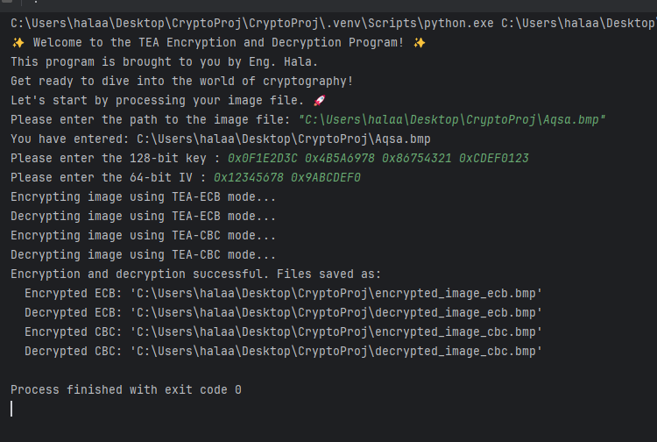

<https://github.com/Hala-Mohammed56/-TEA-ECB-and-TEA-CBC->